Steve Cook’s numbers are highlighted in yellow. ((line 89))
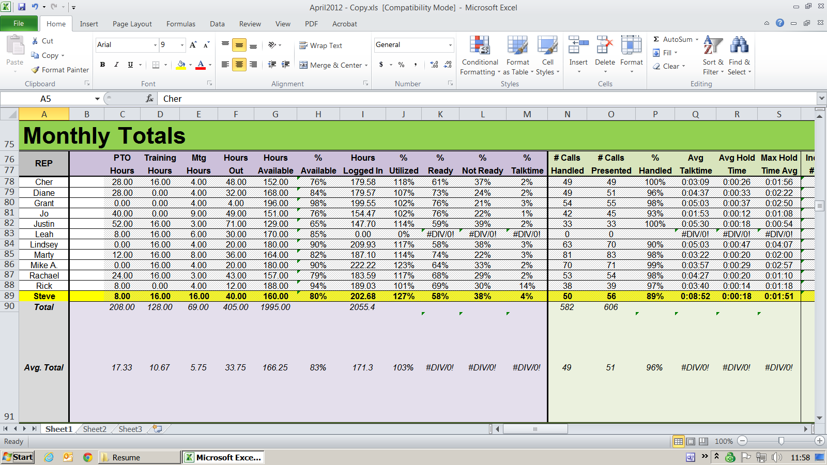

Steve Cook’s numbers are highlighted in yellow. ((line 89))
